**A**

**TECHNICAL REPORT**

**ON**

**STUDENT INDUSTRIAL WORK EXPERIENCE SCHEME (SIWES)**

**UNDERTAKEN AT**

**INTSTRUTECH LIMITED (OIL AND GAS SERVICE COMPANY),**

**PORT HARCOURT,RIVERS STATE.**

**BY**

**ONYIBOR EKENE**

**2021564041**

**300 LEVEL**

**SUBMITTED TO**

**THE DEPARTMENT OF APPLIED GEOPHYSICS,**

**FACULTY OF PHYSICAL SCIENCE,**

**NNAMDI AZIKIWE UNIVERSITY AWKA, ANAMBRA STATE.**

**IN PARTIAL FULFILMENT OF THE REQUIREMENTS FOR THE**

**AWARD OF THE DEGREE IN BACHELOR OF SCIENCE IN APPLIED GEOPHYSICS.**

**DECEMBER, 2024.**

**DEDICATION**

With heartfelt joy, I dedicate this piece to God Almighty on whose strength I rode to this point of my academic work, He had made my feet like hinds feet that I might walk on my high places.To God be the Glory!

**ACKNOWLEDGEMENTS**

Fist and foremost, God Almighty on whose strength I rode to this point of my academic work.

I would have to express my deepest appreciation to my Supervisor Professor T. N. Obekezie for her support during the program

**CHAPTER ONE**

**1.0 INTRODUCTION**

**1.1** **BACKGROUND**

The Industrial Training fund established by decree 43 was introduced in 1971, vis-à-vis the birth of the Students Industrial Work Experience Scheme (SIWES) the same year by the Federal Government of Nigeria (FGN).

It is an integral part of the requirements for the award of Certificates, Diplomas and Degrees in institutions of higher learning, e.g., Colleges of Education, Polytechnics, Universities, etc.

Student Industrial Work Experience Scheme (SIWES) exposes students to industry-based skills necessary for a smooth transition from the classroom to work environments. It accords students of tertiary institutions the opportunity of being familiarised and exposed to the needed experience in handling machinery and equipment which are more often than not, found in such an educational institution.

My six months Industrial Training was observed at *INSTRUTECH LIMITED (OIL AND GAS SERVICE COMPANY), PORT HARCOURT,RIVERS STATE.*

**1.2**  **OBJECTIVES OF SIWES**

* To provide students with relevant practical experience.
* To satisfy accreditation requirements set by the Nigerian Universities Commission (NUC)
* To familiarize students with typical environments in which they are likely to function professionally after graduation.
* To provide student an opportunity to see the real world of their discipline and consequently bridge the gap between the University work and actual practice.
* To change the orientation of students towards labour market when seeking for job.
* To help students access area of interest and suitability for their chosen profession.
* To enhance students, contact for future employment
* To provide access to equipment and other facilities that would not normally be available in the University workshop
* To enlist and enhance industry involvement in university education.
* Summarily the objective of the Student Industrial Work Experience Scheme.
* To solve, the problem of inadequate practical skills, preparatory for employment in industries by Nigerian graduates of tertiary institution.
* To promote and encourage the acquisition of skills in industry and commerce, with a view of generating a pool of indigenous trained manpower sufficient to meet the needs of the economy.

**CHAPTER TWO**

**2.0 INTRODUCTION**

**2.1 Historical survey of Instrutech Limited (oil and gas service company).**

Instrutech Limited is an indigenous integrated Oil and gas servicing company with over 14 years of operation. Their core services are in electrical and instrumentation, mechanical, electrical and electronics instrumentation, construction, installation, calibration, repairs, maintenance, pre-commissioning and commissioning. Also of interest is pipeline integrity:- corrosion control/cathodic protection and painting. Valves and actuators refurbishment and testing, control panels design, fabrication, installation and commissioning. lifting inspection and NDT services (MPI,DPI & UT). Fire and gas detection systems, lightening protection and earthing systems, flowline & pipeline installation & commissioning. Instrutech Limited have obtained ISO 9001:2015 Quality Management Certification.

**2.2 Vision Statement of Instrutech Limited.**

To be an engineering, Oil and Gas servicing Company with perfection in Construction and maintenance of oil and gas field Engineering, quality inspection, training programs, and providing world-class services to our clients.

**2.3 Mission Statement of Instrutech Limited.**

To become a company widely known for quality, cost effective and timely service delivery in the engineering and oil industry.

To produce our services in an environmentally friendly and safest manner that will reflect the core value of our clients/customers.

To earn the admiration of our clients/customers and employees, not only for the goal achieved, but for how best we achieve them creditabl**y.**

**2.4 The Core Values of Instrutech Limited.**

Instrutech Limited is a value driven company committed to providing excellent services at affordable technical expertise and sustaining a development based network in the oil and gas industry. our core values are INTEGRITY, PURSUIT OF EXCELLENCE, HONESTY, ACCOUNTABILITY, SOCIAL RESPONSIBILITY and CAREER DEVELOPMENT

**2.5 Instrutech Limited (Oil and Gas service company) Organizational chart.**

**2.6 Various departments and functions.**

Administrative department

QA/QC department

Asset department

Security department

Logistics Department

Engineering department

HSE department

**2.7 FUNCTIONS**

**Administrative Department**

This department is primarily responsible for managing the day-to-day operations of the company, including tasks like record keeping, document management, scheduling, communication, office supplies, asset management, and ensuring compliance with company policies and regulations, essentially facilitating smooth workflow across the company by handling logistical and administrative support functions.

**Quality assurance and Quality control (QA/QC) Department**

The QA/QC department is one of the most crucial departments in the company. This department is responsible for ensuring that products and services meets every customers expectation. i.e: training,documentation, monitoring and audits.

**Assets Department**

This department has many functions, including: risk management, asset tracking,compliance,lifecycle management, portfolio management, inventory management, regulatory compliance.

**Logistics Department**

The logistics department is responsible for the planning, organization, and coordination of the movement of goods and services within the company. This includes: transportation, storage, warehousing, inventory control, order fulfilment, materials handling, supply chain management, customer service, etc.

**Engineering Department**

This department perform a variety of functions, including: Designing and development, testing and evaluating, maintaining and preserving, enforcing regulations, inspection, developing goals, advising stakeholders.

**Security Department**

This department is one of the most crucial departments in the company responsible for the safety of the company's properties and staffs, including: preventing losses, responding to emergencies, monitoring, ensuring access control, protecting information, etc.

**HSE Department**

The health, safety and environment (HSE) department supervise the operation of any potential hazards in the workplace. This department improve worksplace safety and employee productivity, including: risk assessment, risk management, training and development, communications, emergency management, regulatory compliance, etc.

**CHAPTER THREE**

**3.0 ACTIVITIES DURING THE SIWES PERIOD**

**3.1 CALIBRATION**

Calibration is the process of configuring and verifying the accuracy of measurement instruments or equipment to ensure their readings match known standards. Or Instrument calibration is the process of comparing the measurements obtained from an instrument under test (IUT) to a known standard. The standard has a defined magnitude or value, which is more accurate than the IUT. Discrepancies between the IUT and the standard can then be corrected or documented. Calibration:

1. Establishes instrument accuracy and reliability.

2. Compares instrument readings to certified standards.

3. Adjusts instrument settings to eliminate deviations.

4. Documents calibration results for traceability

Across multiple sectors, calibration plays a vital role in ensuring accuracy and reliability. These sectors includes:

1. Aerospace

2. Automotive

3. Healthcare

4. Food Processing

5. Oil and Gas

6. Pharmaceuticals

7. Power Generation

**3.1.1 TYPES OF CALIBRATION:**

**1. Initial calibration**: Initial calibration is also known as "as-new" or "initial verification" calibration, is the first calibration performed on a newly purchased or installed instrument or equipment. This calibration:

1. Verifies instrument accuracy and performance.

2. Ensures compliance with manufacturer specifications.

3. Establishes a baseline for future calibrations.

4. Confirms instrument functionality and reliability.

2**. Routine calibration**: Routine calibration is also known as scheduled calibration or periodic calibration, is the regular calibration of instruments or equipment at predetermined intervals to ensure ongoing accuracy and This calibration:

1. Maintain instrument accuracy and precision

2. Prevent measurement drift and errors

3. Ensure regulatory compliance

4. Optimize instrument performance

5. Extend instrument lifespan

3. **As-found calibration: A**s-found calibration, also known as "before maintenance" or "pre-maintenance" calibration, is the calibration of an instrument or equipment before maintenance, repair, or servicing. This calibration:

Determines the instrument's accuracy and condition before maintenance.

Identifies potential issues or deviations.

Provides a baseline for comparison after maintenance.

**4. As-left calibration: A**s-left calibration, also known as "after maintenance" or "post-maintenance" calibration, is the calibration of an instrument or equipment after maintenance, repair, or servicing. This calibration:

Verifies instrument accuracy and performance after maintenance.

Ensures adjustments or repairs did not affect calibration.

Confirms instrument meets specifications.

**3.1.2 IMPORTANCE OF CALIBRATION**

1. Calibration ensures measurement accuracy.

2. Calibration reduces measurement uncertainty.

3. Calibration enhances product quality.

4. Calibration maintains regulatory compliance.

5. Calibration optimizes instrument performance.

6. Calibration extends instrument lifespan.

7. Calibration reduces costs associated with errors.

**3.1.3 Common calibration standards:**

1. ISO 9001 (Quality Management)

2. ISO/IEC 17025 (Laboratory Competence)

3. NIST (National Institute of Standards and Technology)

4. ANSI (American National Standards Institute

**3.1.4 Instruments commonly calibrated:**

1. Thermometers

2. Pressure gauges

3. Flow meters

4. Weight scales

5. Electrical multimeters

6. Temperature controllers

7. pH meters

**3.2 INSTRUMENTATION**

Instrumentation refers to the process of measuring, controlling, and monitoring various physical parameters in industrial processes, systems, and facilities using specialized devices and equipment. Instrumentation involves:

**1. Measurement**: Sensing and quantifying physical parameters such as:

i. Temperature

ii. Pressure

iii. Flow rate

iv. Level

v. pH

vi. Conductivity

vii. Speed

viii. Vibration

2**. Control:** Regulating and adjusting processes using:

i. Controllers (e.g., PID, logic)

ii. Actuators (e.g., valves, motors)

iii. Sensors (e.g., temperature, pressure)

3. **Monitoring:** Observing and displaying process data using:

i. Indicators (e.g., gauges, displays)

ii. Recorders (e.g., chart recorders, data loggers)

iii. Alarm systems

**3.2.1 TYPES OF INSTRUMENTATION:**

1**. Process instrumentation:** is the use of instruments and control systems to measure and control physical quantities in industrial processes. These quantities include temperature, pressure, flow, level, pH, and other relevant variables. Process instrumentation is essential for manufacturing and process management. It helps to: Improve process efficiency

Increase process quality

Detect anomalies

Ensure safety.

**2. Test and measurement instrumentation:** Test and measurement instrumentation is a type of equipment that measures and tests various parameters to ensure the proper functioning of a device or application. Test and measurement instruments can be used to measure: Voltage, Current, Resistance, Frequency, Capacitance, Temperature, Continuity, Data transmission rates, and Power. Test and measurement instruments work by creating signals and reading the device's response. Variations in the response can help identify and fix faults. (e.g., multimeters, oscilloscopes)

**3. Control instrumentation:** Control instrumentation, also known as instrumentation and control, is the process of measuring, analyzing, and controlling industrial process variables. It uses hardware and software to monitor and control physical properties of a process or material, such as pressure, flow, temperature, and level. Control instrumentation systems ensure optimal performance and safety by measuring and controlling physical quantities. Some examples of control instrumentation include:

Weight measurement system

Flow measuring system

Pressure gauge

Sensor

Circuit

breaker

Valve

Solenoid

Relays.

**4. Analytical instrumentation:**  Analytical instrumentation is the science of using instruments to acquire, process, and interpret data about the composition and properties of substances. Analytical instruments can be used in many fields. (e.g., chromatographs, spectrometers)Analytical instruments are made up of four basic components: a chemical information source, transducers, signal conditioners, and a display system. Some examples of analytical instruments include: Rubber testing equipment and Gas chromatographs.

**3.2.2 IMPORTANCE OF INSTRUMENTATION**

1. Improved process efficiency

2. Enhanced product quality

3. Increased safety

4. Reduced costs

5. Real-time monitoring and control

6. Data-driven decision-making

7. Compliance with regulations

**3.2.3 DEVICES USED IN INSTRUMENTATION**

1. Sensors

2. Transmitters

3. Controllers

4. Actuators

5. Valves

6. Pumps

7. Meters (e.g., flow, pressure)

8. Gauges (e.g., temperature, pressure)

9.Air compressors

Instrumentation plays a vital role in ensuring efficient, safe, and reliable operation of industrial processes and systems.

During my industrial training,I used some equipments below for calibration.

1. **Pressure gauge:** The term pressure gauge usually refers to a self-contained indicator that converts the detected process pressure into the mechanical motion of a pointer. Pressure gauges can either be mechanical or digital. The first pressure gauges used flexible elements as sensors.

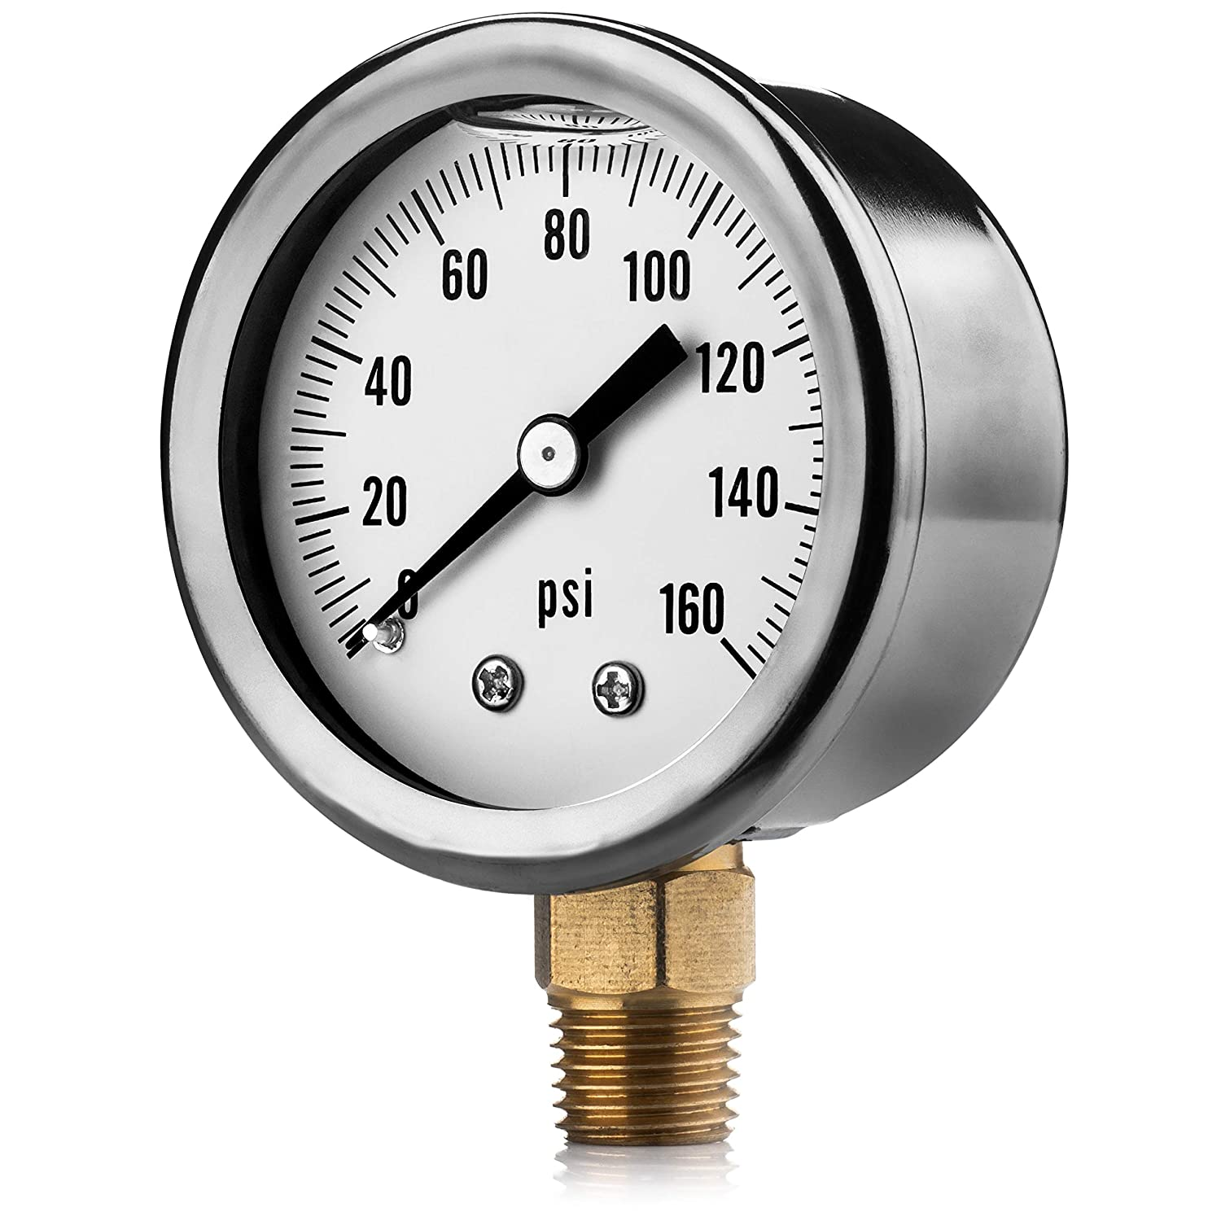

**2. Pressure hand pump:** Hand pumps are manually operated pumps; they use human power and mechanical advantage to move fluids or air from one place to another.

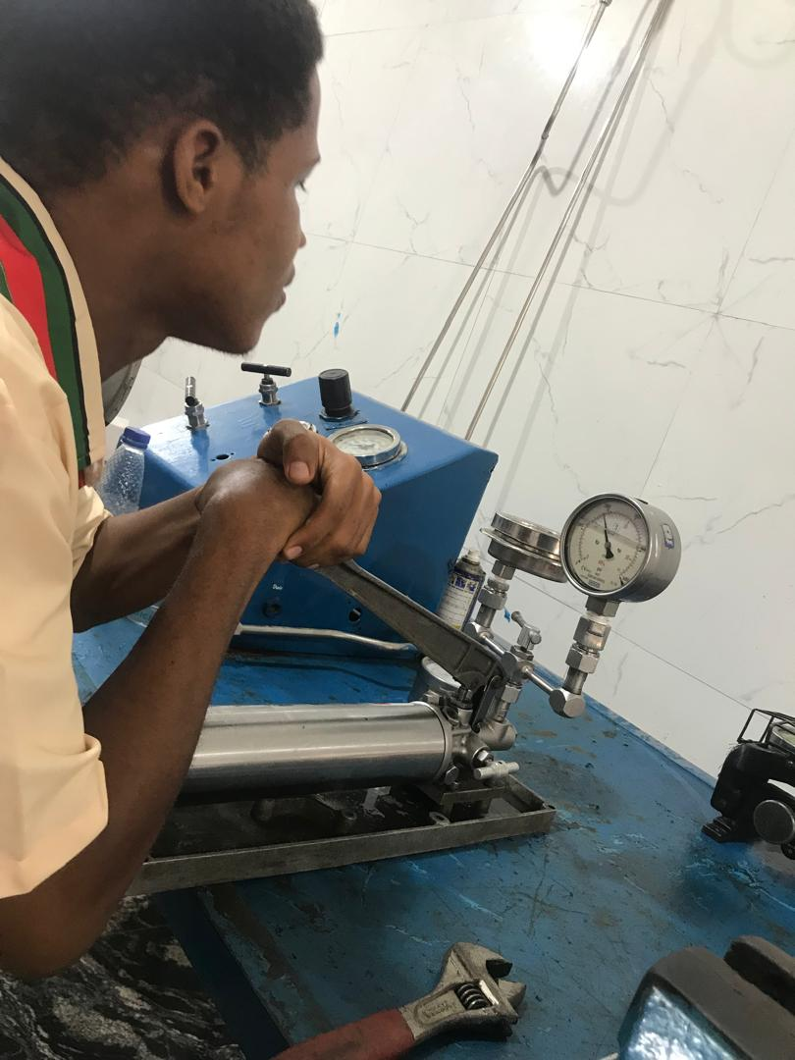

3**. Pressure recorder**: pressure recorder is a device that measures and records pressure variations. Pressure recorders can be used to track pressure

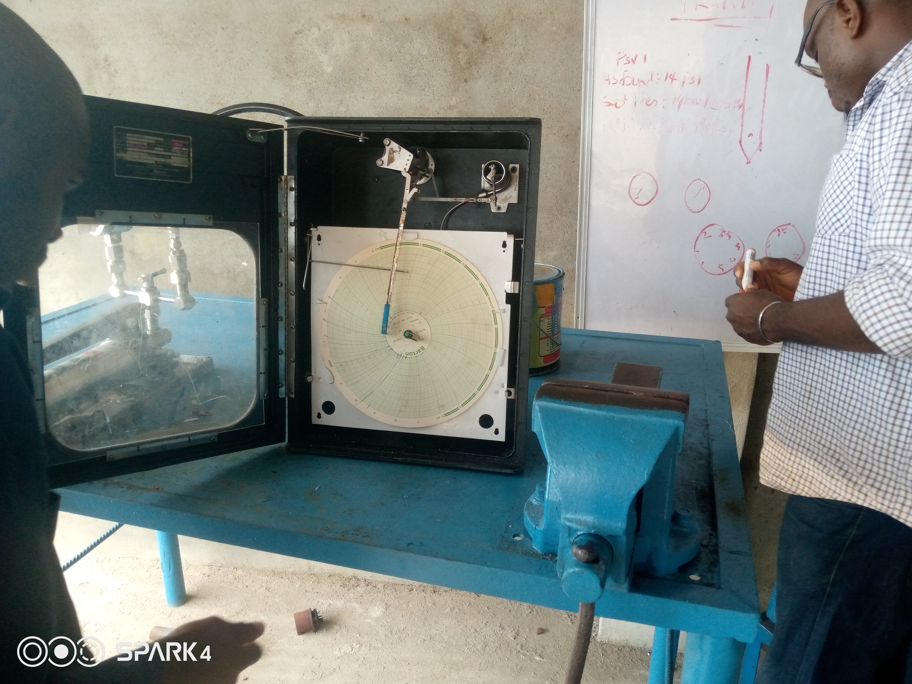

**4. Air compressor**: an air compressor is a machine that takes ambient air from the surroundings and discharges it at a higher pressure. It is an application of a gas compressor and a pneumatic device that converts mechanical power (from an electric motor, diesel or gasoline engine, etc.) into potential energy stored in compressed air, which has many uses.

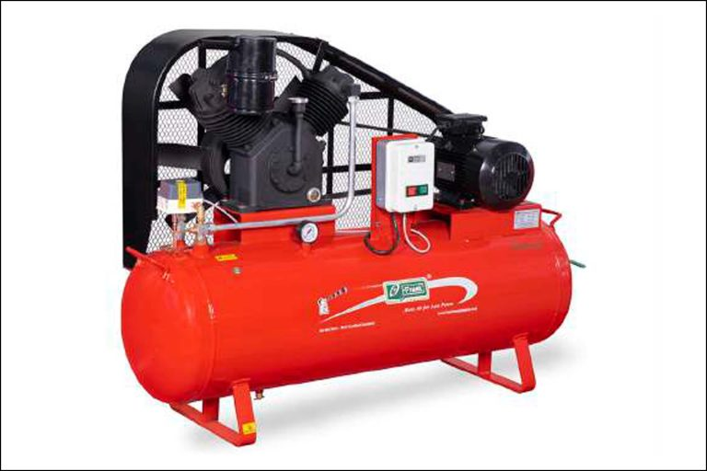

5. **Hydrostatic pump:** Hydrostatic test pumps are self-contained units designed to generate and maintain high pressure within a system. They typically consist of a pump mechanism, a pressure gauge, a reservoir, and a system of valves and hoses. The pump mechanism, powered by either manual operation, electricity, or a gasoline engine, forces water from the reservoir into the system being tested. The pressure gauge allows the operator to monitor and control the applied pressure, ensuring adherence to specific testing requirements. Valves and hoses facilitate the connection of the pump to the system and control the flow of water during the test.

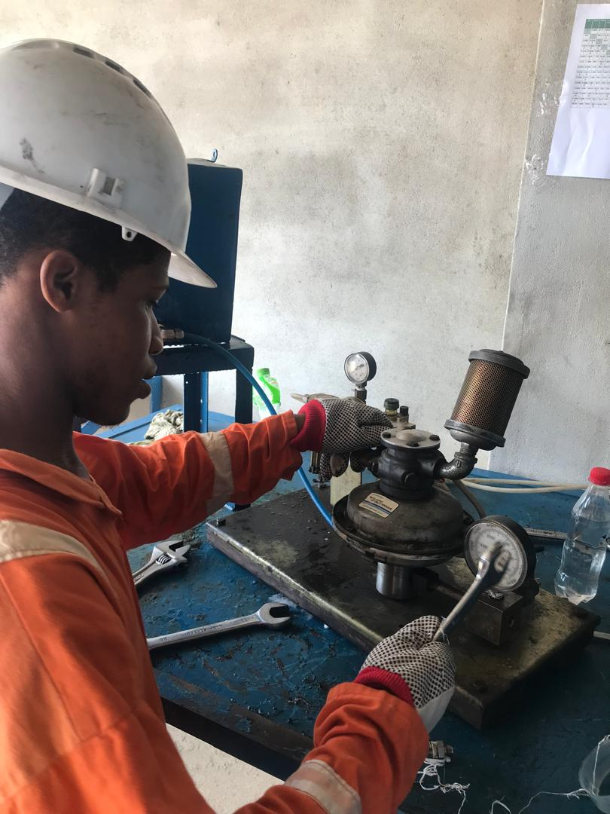

**6. Fluke 754 Documenting Process Calibrator-HART:**Fluke 754 Documenting Process Calibrator with HART communication does the work of many tools. Whether you're calibrating instruments, troubleshooting a problem, or running routine maintenance, the Fluke 754 with HART® communication can help you get the job done faster. It does so many different tasks, so quickly and so well, it's the only process calibrator you need to carry. This rugged, reliable integrated communicating calibrator is ideal for calibrating, maintaining, and troubleshooting HART and other instrumentation. In fact, the 754 does the work of several tools. It sources, simulates and measures pressure, temperature, and electrical signals with one rugged, hand-held device. For documentation, the 754 automates calibration procedures and captures your data. And, of course, it helps you meet rigorous standards like ISO 9000, FDA, EPA and OSHA regulations. Plus, the new improved graphical screen, Li-Ion battery for longer life, USB port, and accessories help you work smarter and faster.

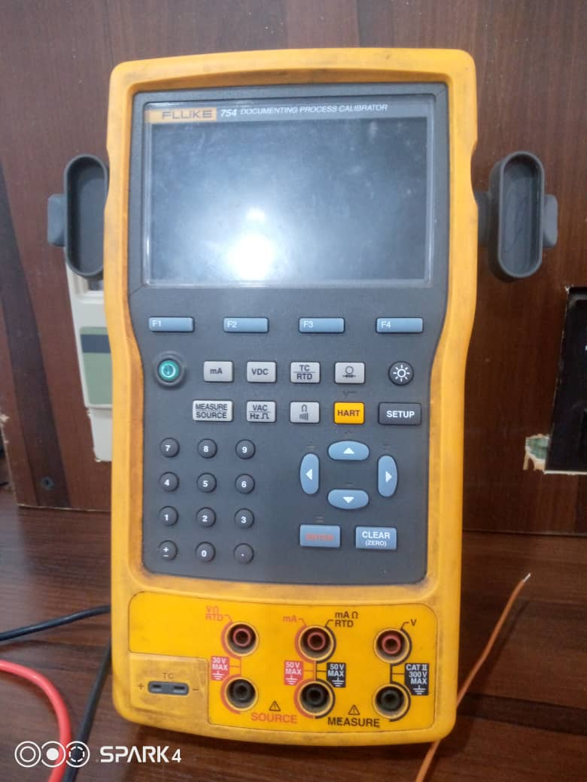

**3.3 CALIBRATING A PRESSURE GAUGE**

Here are the 5 steps for pressure gauge calibration using a hand pump.

**1. Preparation:** Before calibration, ensure that the pressure gauge is clean and free from any visible damage or debris. Also, identify the reference standard and ensure that it is calibrated and traceable to a recognized standard.

**2. establish the calibration range:** Determine the upper and lower limits of the gauge, and then set up the calibration equipment to cover the calibration range.

**3. Calibration Procedure:** Connect the pressure gauge to the reference standard and record the reading. Compare the reading with the reference standard and adjust if necessary. Repeat the process at various points within the calibration range.

**4. Record Keeping:** Record all the data obtained during the calibration process, including the calibration range, reference standard used, and any adjustments made. This record should also include the date, time, and technician responsible for the calibration.

**5. Certificate of Calibration:** Issue a certificate of calibration to confirm that the gauge has been calibrated within its specified range and is fit for use. The certificate should include the calibration range, reference standard used, and any adjustments made, as well as the date and technician responsible for the calibration.

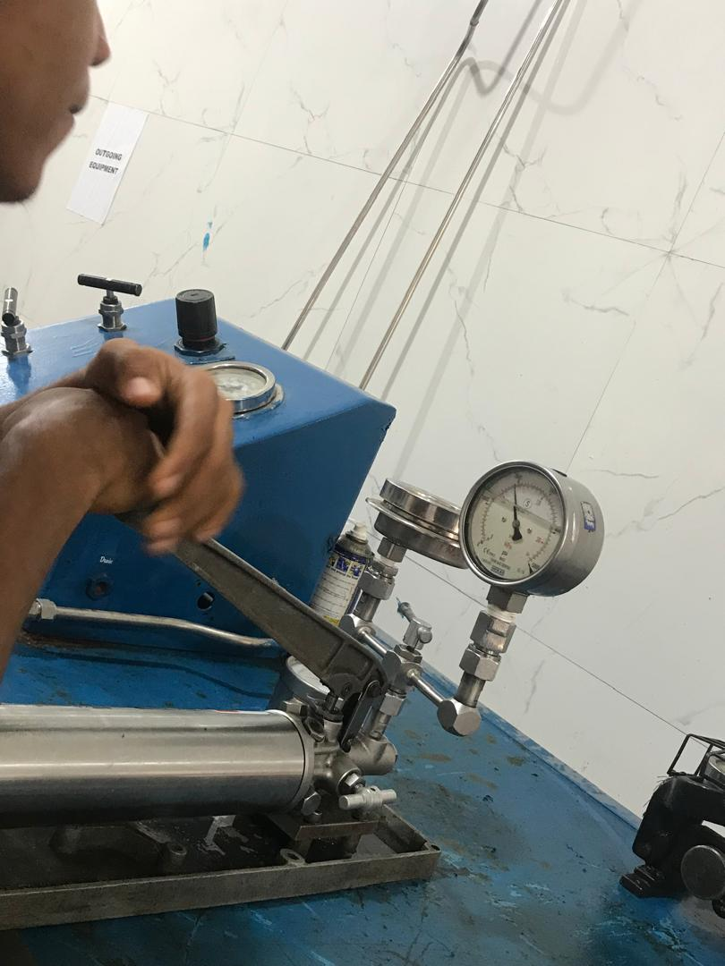

**3.4 CALIBRATING A PRESSURE RECORDER**

**Calibrating a pressure recorder using a pressure hand pump:**

Step 1: Apply known range pressure by a dead weight tester or 3-15 psi by precision regulator.

Step 2: Apply full range pressure to recorder. Adjust linkage to recorder so that pointer is max reading on the chart scale.

Step 3: Reduce pressure to zero and check the pointer reads zero on the chart.Adjust pointer if necessary.

Step 4: Repeat the steps 2 and 3 until both readings are correct.

Step 5 : Recorder linearity adjustment by keeping the signal 50 % of max reading on the chart. Adjust 50%.

Step 6 : Check the reading for 0%, 50% and full scale. you may need to adjust many times till the recorder readings are correct.

Step 7 : Record all readings on Calibration sheet.

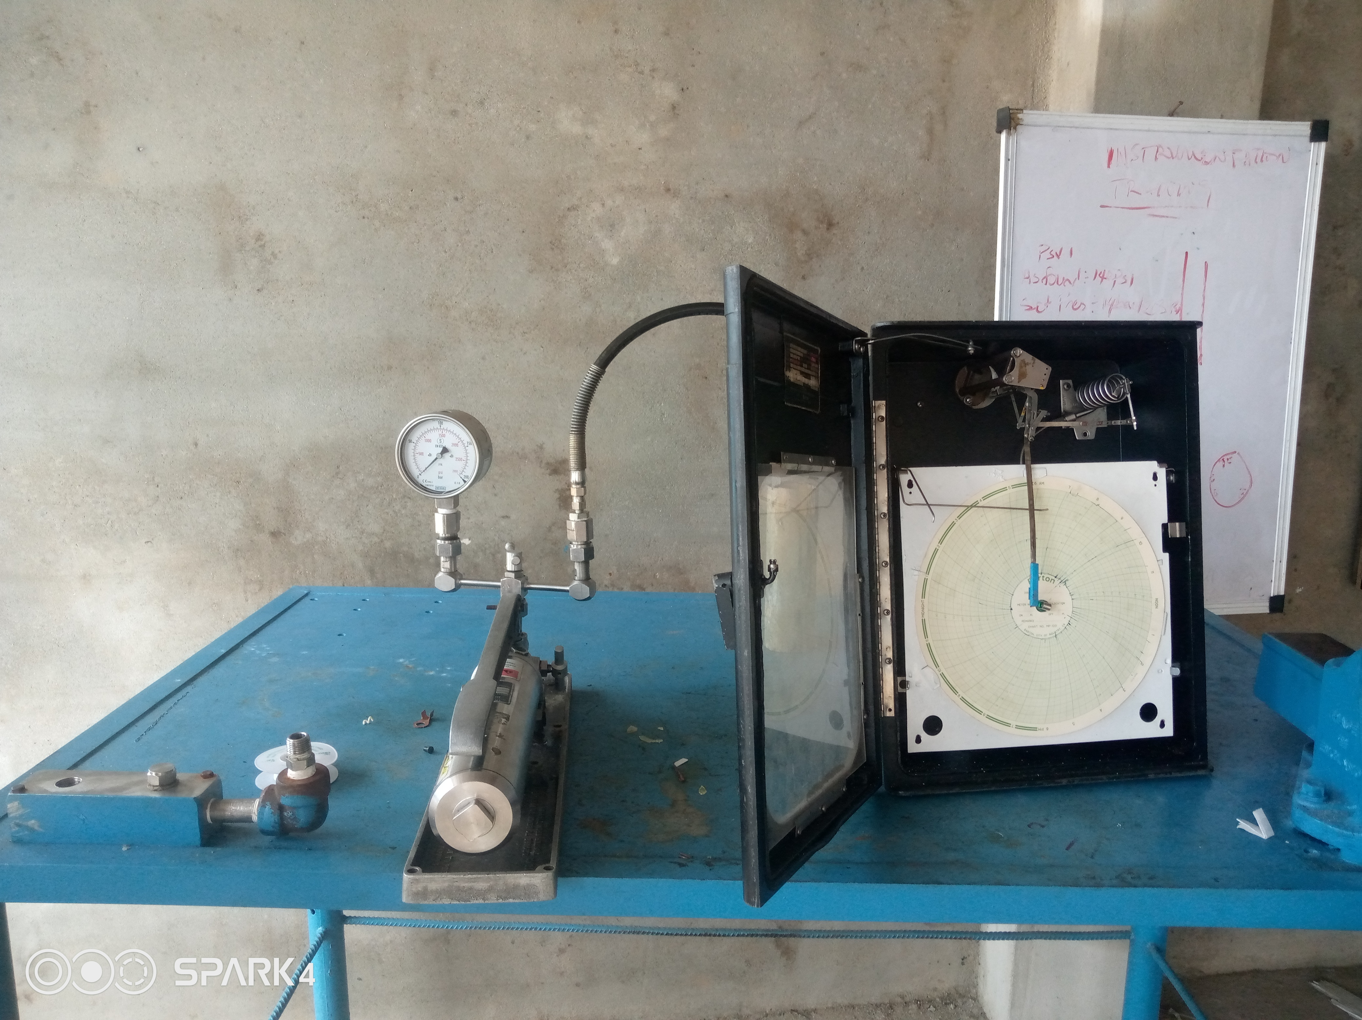

**3.5 MEASUREMENTS**

Measurements refer to the process of quantifying physical parameters or attributes using instruments and tools. Here are some key aspects of measurements:

**3.5.1 Types of measurements**

1. Length (distance, height, width)

2. Mass (weight, density)

3. Time (duration, frequency)

4. Temperature (°C, °F, K)

5. Pressure (force, torque)

6. Flow (rate, volume)

7. Level (height, depth)

8. Speed (velocity, acceleration)

9. Electrical (voltage, current, resistance)

10. Chemical (pH, concentration)

**3.5.2 Units of Measurements**

1. Metric (SI) units (e.g., meters, grams, seconds)

2. Imperial units (e.g., inches, pounds, degrees Fahrenheit)

3. Customary units (e.g., feet, pounds, degrees Celsius)

**3.5.3 Measuring devices/Instrumentation Equipment**

Bow are some measuring devices used in calibration and instrumentation, welding etc.

1. Rulers

2. Scales

3. Thermometers

4. Pressure gauges

5. Flow meters

6. Level sensors

7. Tachometers

8. Multimeters

9. Spectrophotometers

10. Calipers

11. Measuring tape.

**3.5.4 Application of Measurements**

Measurements involves our everyday life, below are some applications of measurements;

1. Quality control

2. Research and development

3. Industrial automation

4. Medical diagnostics

5. Scientific research

6. Engineering design

7. Manufacturing

8. Environmental monitoring

9. Aerospace

10. Automotive

**3.5.5 Measurements parameters:**

1. Accuracy

2. Precision

3. Resolution

4. Sensitivity

5. Repeatability

6. Reproducibility

7. Linearity

8. Calibration

Measurements play a crucial role in various fields, ensuring accuracy, precision, and reliability in data collection and decision-making

**PRESSURE SKID**

A pressure skid typically refers to a specialized trailer or skid-mounted system designed for transporting and operating high-pressure equipment, often used in industries such as:

1. Oil and gas

2. Chemical processing

3. Refining

4. Power generation

5. Industrial cleaning

Pressure skids usually feature:

- High-pressure pumps

- Compressors

- Tanks

- Valves

- Piping

These systems are engineered to handle high-pressure fluids, gases or liquids, and are often customized for specific applications.

Below is a low pressure pressure skid used for practicing.

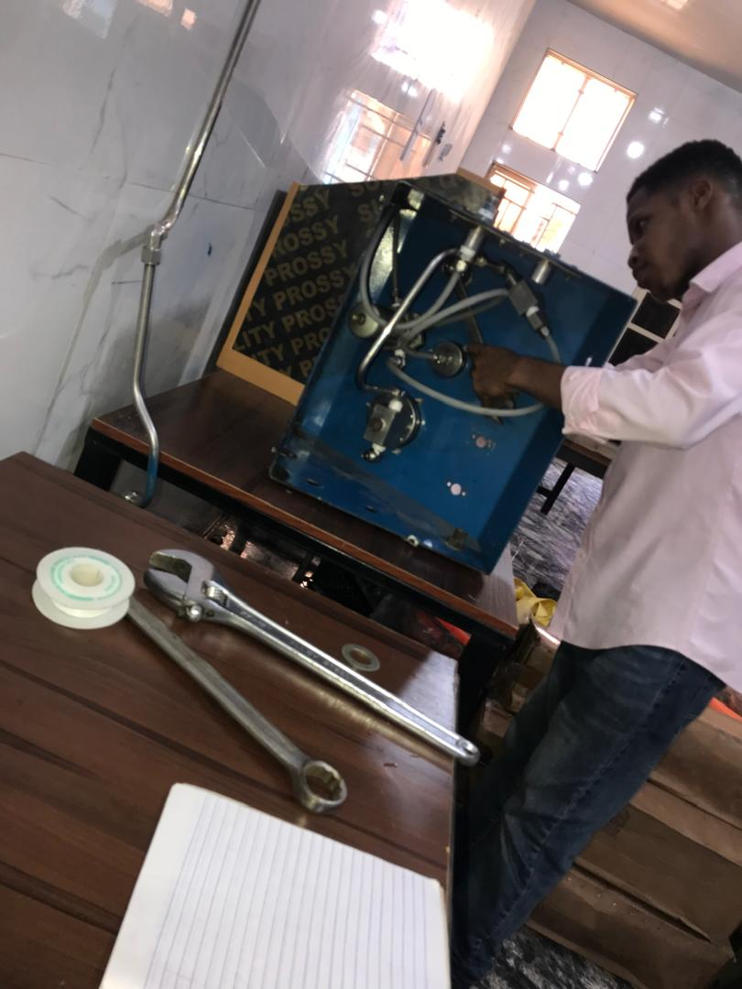

**FITTINGS**

Fittings are components used to connect, adapt, or modify pipes in various plumbing, piping, and tubing systems. Fittings are commonly used in pressure skids. They're essential for creating secure, leak-resistant, and efficient connections. Here are some common types of pipe fittings:

1. Elbows: Change direction of pipe (45°, 90°, 180°)

2. Tees: Connect three pipes (equal or reducing sizes)

3. Couplings; Join two pipes (equal sizes)

4. Adapters: Connect pipes of different sizes or materials

5. Unions: Allow for easy disconnection and reconnection

6. Flanges: Connect pipes to valves, pumps, or equipment

7. Valves: Control flow (gate, ball, needle, check)

8. Caps: Seal pipe ends

9. Plugs: Seal pipe ends (male thread)

10. Nipples: Short pipes for connecting fittings

Below is a comprehensive diagram of the fittings listed above.

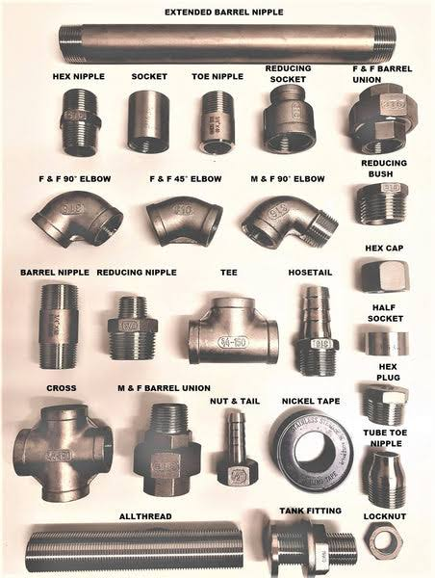

**PERSONAL PROTECTIVE EQUIPMENT (PPE)**

PPE is an equipment worn to minimize espouse to hazards that cause serious workplace injuries. Personal protective equipment (PPE) is clothing, helmets, goggles, or other equipment that protects the wearer from injury or infection. PPE can protect against a variety of hazards, including: Physical hazards, Electrical hazards, Heat, Chemical hazards, Biohazards, and Airborne particulate.

**Types of personal protective equipment (PPE)**

1. Safety helmet:

2. Gloves

3. Gloves

4. Eye glasses

5. Earplugs

6. Full- body suits

7. Best

8. Safety footwears, etc.

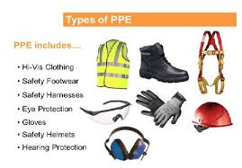

.

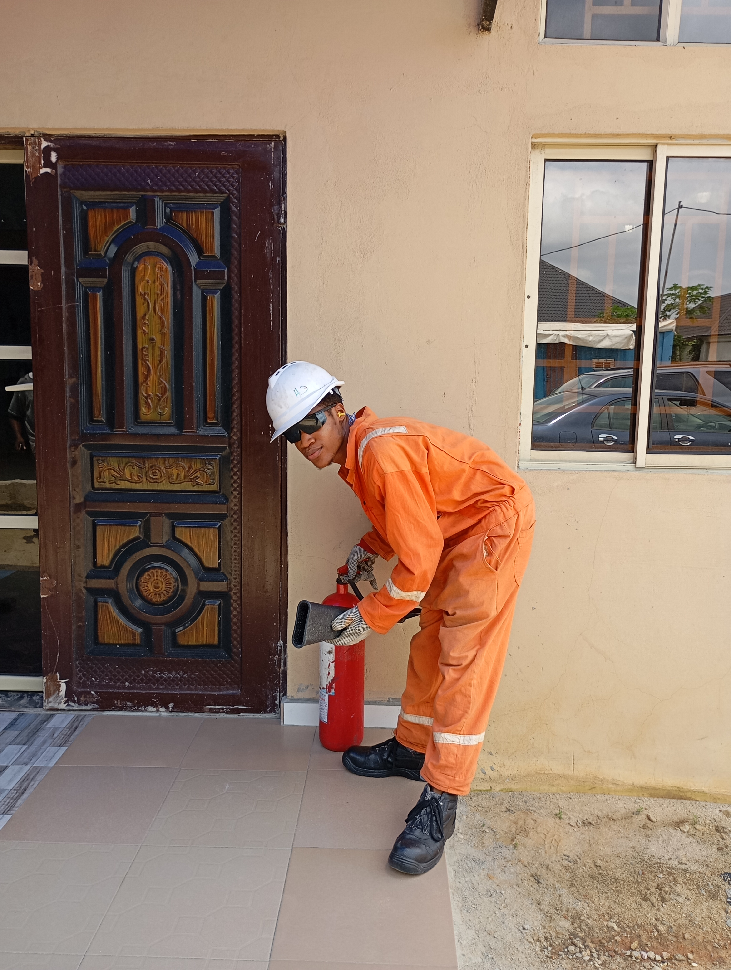

**Safety helmet**

A safety helmet, also known as a hard hat, is a type of personal protective equipment (PPE) designed to protect the head from injuries caused by falling objects, electrical hazards, chemical splashes, and other workplace hazards. Safety helmets are typically worn in industries such as:

1. Construction

2. Manufacturing

3. Mining

4. Oil and gas

5. Electrical

6. Chemical processing

Helmets can be categorised by colours as shown in the diagram below.

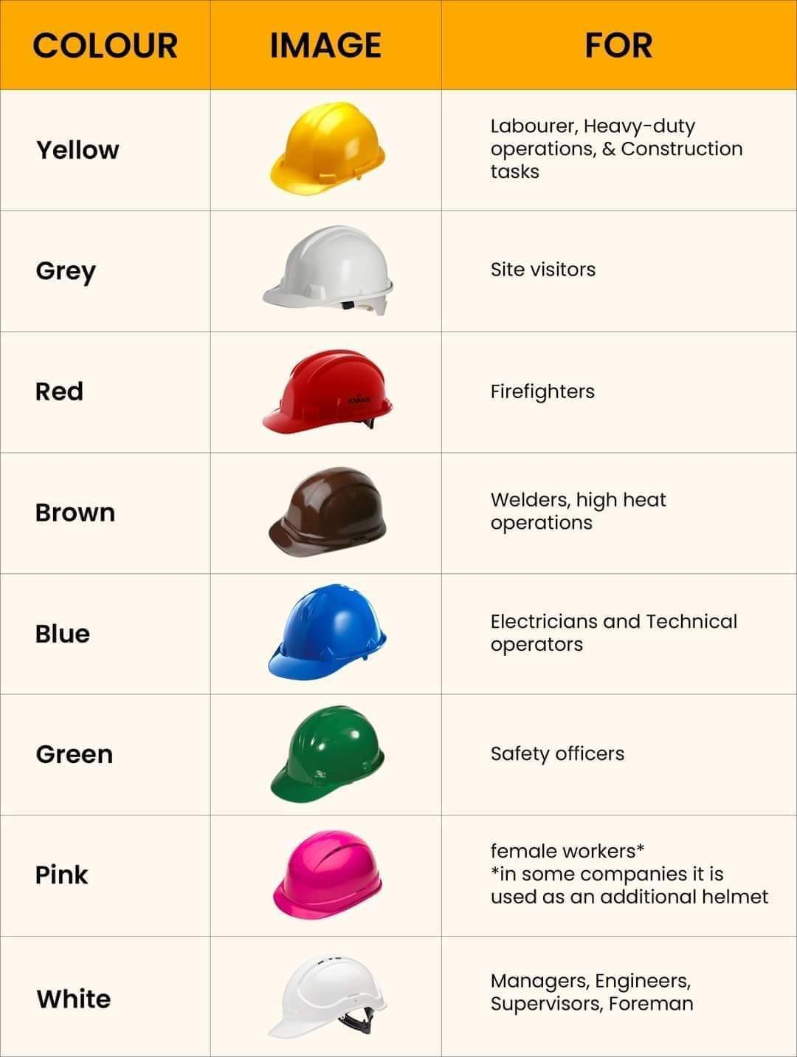

**PPE Protects Against 5 Basic Elements**

PPE is designed for the protection of five basic elements:

1. Head & Feet (e.g. hard hats to protect vs falling items; work boots/shoes for ground hazards)

2. Eyes (e.g. safety glasses/goggles from particles, corrosive liquids, etc.)

3. .Lungs (e.g. respirators employed to prevent breathing in contaminated air)

4. Body (e.g. clothing to keep warm in cold conditions)

5. Skin (e.g. gloves to wear when the risk of burns or corrosion exists)

**Importance of PPE in the Workplace**

PPE is worn to minimize and mitigate the risks and hazards associated with a wide variety of working conditions. Without proper PPE, workers are left exposed to significant risks of injury or illness. These injuries or illnesses may not present themselves immediately either. PPE protects you and your employees from the long-term effects of the nature of your work.

**CHAPTER FIVE**

**5.1 PROBLEMS ENCOUNTERED**

Here are some common problems encountered during my siwes programme.

**Technical Issues:**

1. Difficulty understanding complex instrumentation concepts (e.g., signal processing, sensor principles)

2. Troubleshooting instrumentation faults and errors

3. Inability to interpret calibration data and results

4. Familiarity with various calibration standards and protocols (e.g., ISO, NIST)

5. Understanding measurement uncertainty and its impact on calibration

**Practical Challenges:**

1. Handling delicate instrumentation equipment

2. Setting up and configuring calibration systems

3. Conducting calibration procedures efficiently and accurately

4. Ensuring environmental conditions (e.g., temperature, humidity) are suitable for calibration

5. Managing calibration data and documentation

**Knowledge Gaps**

1. Limited understanding of instrument specifications and capabilities

2. Insufficient knowledge of industry-specific regulations and standards

3. Lack of familiarity with calibration software and tools

4. Difficulty understanding instrument communication protocols (e.g., HART, Profibus)

5. Limited awareness of instrument maintenance and repair best practices

**Safety Concerns:**

1. Electrical safety when working with instrumentation

2. Handling hazardous materials or processes

3. Ensuring personal protective equipment (PPE) is used correctly

4. Understanding emergency procedures and shutdown protocols

5. Familiarity with lockout/tagout procedures

**Soft Skills:**

1. Time management and organization during calibration tasks

2. Effective communication with colleagues and supervisors

3. Documentation and record-keeping skills

4. Attention to detail and quality control

5. Adaptability to new instrumentation technologies and techniques

**Training Environment:**

1. Limited access to instrumentation equipment and resources

2. Insufficient instructor guidance or support

3. Difficulty replicating real-world calibration scenarios

5. Limited opportunities for hands-on practice and reinforcement.

**5.2 WAYS OF IMPROVING THE PROGRAMME:**

**1**. Creating stronger partnerships between educational institutions, industries, and government agencies to ensure a more comprehensive and practical SIWES programme.

2.Regularly update and align the SIWES curriculum with industry needs to equip students with relevant skills and knowledge.

3. Ensure effective supervision during SIWES placements to guarantee that students receive meaningful learning experiences and contribute meaningfully to their host organizations.

4. Incorporate career counseling and guidance sessions to help students make informed decisions about their future career paths based on their SIWES experiences.

**5.3 ADVICE TO FUTURE PARTICIPATE**

1.When you get a place for your IT, be on time. Punctuality demonstrates your commitment and respect for others' time.

2. Don't wait for instructions all the time. Be proactive, and show eagerness to contribute to tasks and projects.

3. Relate with professionals in your field and also the management.

4. Building relationships during SIWES can open doors for future opportunities and provide valuable insights.

5. Keep a journal or record of your daily activities and lessons learned. This can be a valuable resource for reflection and future reference.

6. Good communication is key. Whether it's verbal or written, express yourself clearly and listen attentively. This skill is vital in any workplace.

4. Every person you meet has something to teach you. Learn from colleagues, supervisors.

**5.4 ADVICE FOR SIWES MANAGER**

The SIWES is no different from the training of old, it is only a little bit modified, SIWES is designed to give student of universities, polytechnics etc. an avenue for applying the skill they've acquired while in school, the SIWES is also undertaken while the individual is still in the school.

The federal government should make adequate provision in the annual budget for proper funding of SIWES in view of the potential of the scheme.

Institutions shouldn't just dish out this student to various organizations and firms for the sake of industrial training but should take proper care and visit them every two weeks for proper monitoring.